****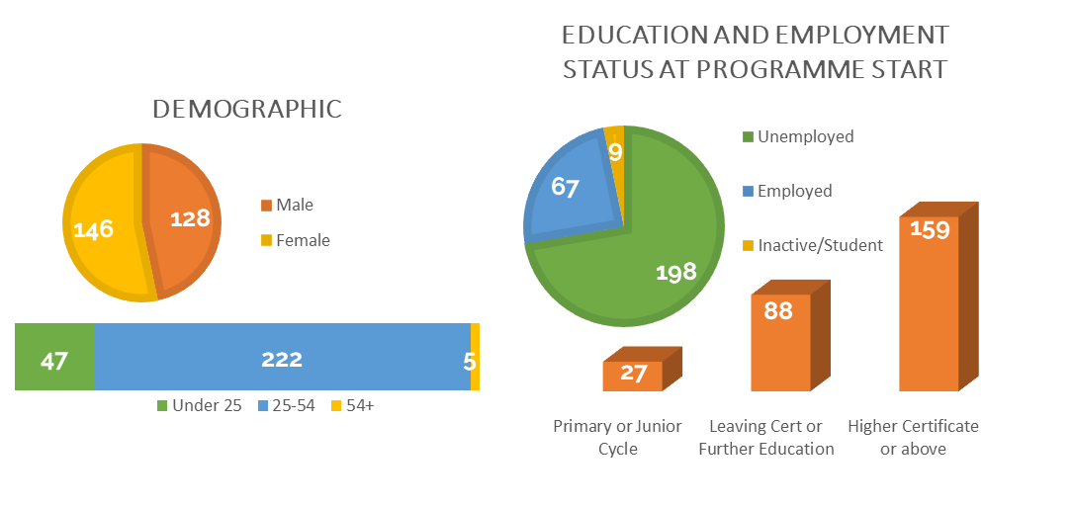

Career KickStart Programme 2021-2022

Project evaluation as part of IPS ESP

274 PARTICIPANTS

**11** employment support workshops

**107** participants in online and in-class training and **123** One-to-One career support sessions with a job coach

**6** online

Accredited Cambridge English and Cambridge Business English courses.

**68%** completed courses and passed exam out of **111** attendees

**2** Job Fairs

in County Meath & Louth

**343** attended

**24** vocational courses

**126** participants attended online and in-class training

Secured employment immediately after programme completion

IMPACT

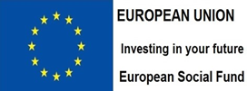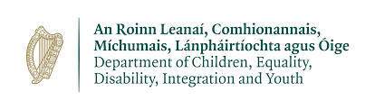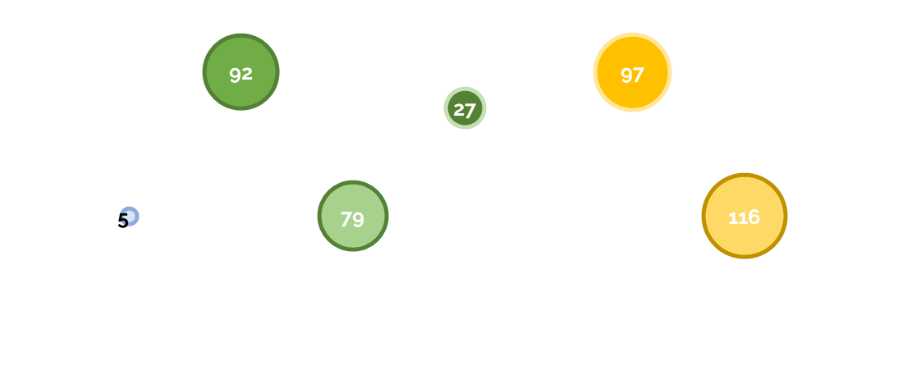

This project is supported by the Migrant Integration Policy, Inclusion Unit and the Department of Children Equality, Disability, Integration and Youth.

Entered training or further education during or upon completion of the programme

Gaining a qualification upon leaving

Improved labour market situation (e.g. promotion or better job)

In new employment within 6 months after completing

Inactive at the start, engaged in job searching upon leaving