CULTÚR CELEBRATING DIVERSITY

Community Worker Job Description
The Community Worker will promote and support the Mission of Cultúr in all work undertaken

CULTÚR MISSION STATEMENT
To promote the empowerment, participation, self- determination and rights of ethnic minorities who experience, or are at risk of experiencing, poverty, social exclusion and racism.

Job Title | Community Worker
Location of post | Cultúr Office in Dundalk, Co Louth & liaising with Navan office as requires. | Pay | €37,000 P/A  (Fulltime)
Hours/Time | 35 Hours per week Evening & weekend work might be required. 9.30am – 5.30pm | Duration of job | Until November 2022, with the possibility to extend to the end of November 2024, subject to funding.
Purpose of the position: The successful candidate will be responsible for the implementation of Migrant Network Community Development Project Louth & Meath, funded by Department of Rural and Community Development. The overall aim of this project is to widen the participation and promote the empowerment and inclusion of migrants, asylum seekers and refugees, working in collaboration with agencies and organisations in the community. Candidates will be expected to be dynamic and flexible in their approach to work.
Responsible to: Project Coordinator on a day-to-day basis
Consistent with the Strategic goals of Cultúr, the Community Worker will:

- Use a community work approach to identify, engage with and support migrants within County Louth.
- Influence policy development facilitating the social and economic inclusion of migrants, addressing their needs and interests.
- Use a human rights framework to ensure ethnic minorities are aware of and can exercise their human rights as equal members of the community.

Using a Community Work Approach the Community Worker Responsibility will

- Develop community responses to a range of social, economic and environmental concerns
- Facilitate a collaborative approach with the target group to build and empower relationships and cooperative initiatives between marginalised groups, mainstream services and decision-making bodies
- Showcase and profile the benefits of an autonomous approach to community development in relation to new and emerging issues.
- Develop participative research approaches and undertake a collaborative needs assessment of local communities in County Louth with a specific focus on target community.
- Establish structures and mechanisms for ongoing engagement of the target groups
- Engage in the development of Cultúr policy positions and submissions, in line with its aims, objectives and strategic priorities
- The above list is not exhaustive; additional areas of responsibility both in relation to tasks and direct reports may be added over time.

Person Specification
Skills and Knowledge | - Subject knowledge  - Excellent report writing, spoken and written communication skills  - Sensitivity, tolerance and patience  - Cross-cultural awareness and understanding  - Outstanding communication and interpersonal skills  - Excellent group facilitation/group work skills in an intercultural setting  - Ability to inspire and motivate  - Ability to work on own initiative and as a member of a team, working effectively within the support and supervision structures provided to meet high level goals and targets.  - Clear understanding and analysis of integration issues and national infrastructure, including current issues impacting the local and national community sector  - Management of sensitive data and confidential information.  - Ability to absorb, analyse and evaluate data and information from a variety of sources.
Experience | - A proven track record of working with communities of interest/minority groups using community work approaches. (As identified in the “All Ireland Standard for Community Work”)  - Experience working as part of a team and on own initiative  - Good working knowledge of Microsoft office and other relevant computer applications  - Have a proven track record of policy work, networking / interagency working and a good working knowledge of same  - Be able to demonstrate a commitment to Equality, Human Rights and Diversity  - Experience, knowledge and understanding of issues affecting migrants (desirable)  - Experience in the design and delivery of projects and programmes that are outcome driven  - Excellent organisational, administrative, creativity and ICT skills.  - A strong commitment to Equality, Human Rights and Diversity  - Must be solution-focused, outcomes-driven and dynamic in your approach to the position.
Terms of Employment | The position is for a full-time fixed-term Contract of Employment to the end of November 2022, with the possibility to extend to the end of November 2024, subject to funding and the successful completion of a probation period.  The nature of the work may require working unsocial hours i.e. evenings and weekend and access to own transport is essential for all positions given the outreach nature of the posts on offer. The candidate will require a full driver’s licence and will be expected to indemnify the organisation on their insurance policy.  Each working week will be 35 hours. Although the normal working hours are 9.30am – 5.30pm., work outside normal working hours is expected and will be claimed in lieu as outlined in the Staff Handbook.  The full-time salary is €37,000 per annum pro rata. Annual Leave is 25 days per year pro rata. All terms and conditions are subject to the Contract of Employment and policies contained in the Staff Handbook.  A six month probationary period will apply to this position.
Qualifications | - Third level or postgraduate qualification in community work.  - Minimum of 3 years post-qualification professional experience
Referees | Referees are required
Application Process
To apply, please complete the attached application form HERE and email to tinu@cultur.ie or by post to Tinu Achioya Cultúr Migrant Centre, Ground Floor, St. Anne’s Resource Centre Railway St. Navan Co. Meath. Full job description is available here or www.cultur.ie .
Closing date for receipt of application is 5 pm Thursday 25th November 2021. Late applications will not be accepted. Interviews will take place the week of the 6th December 2021.
Cultúr is an Equal Opportunities Employer.
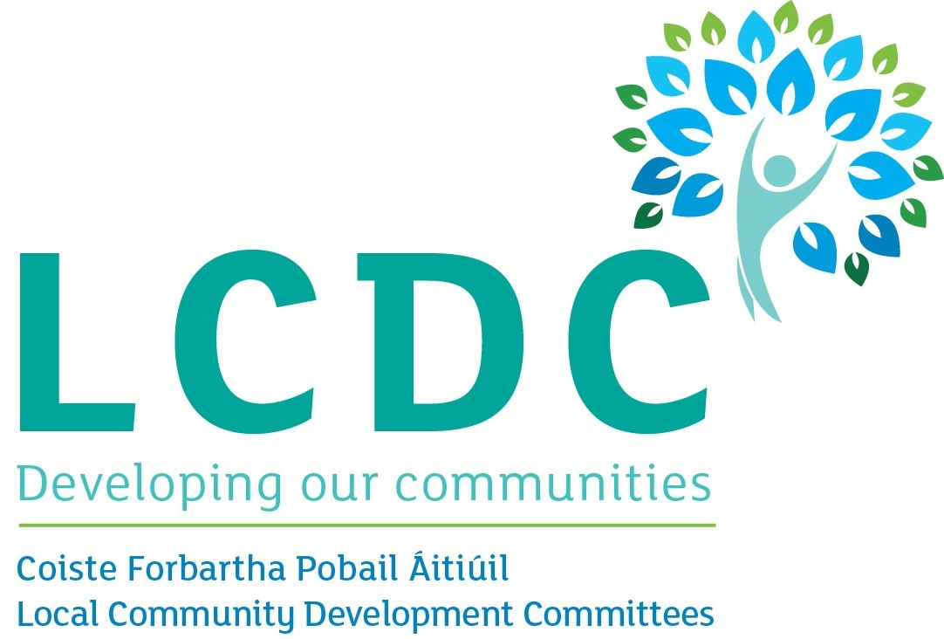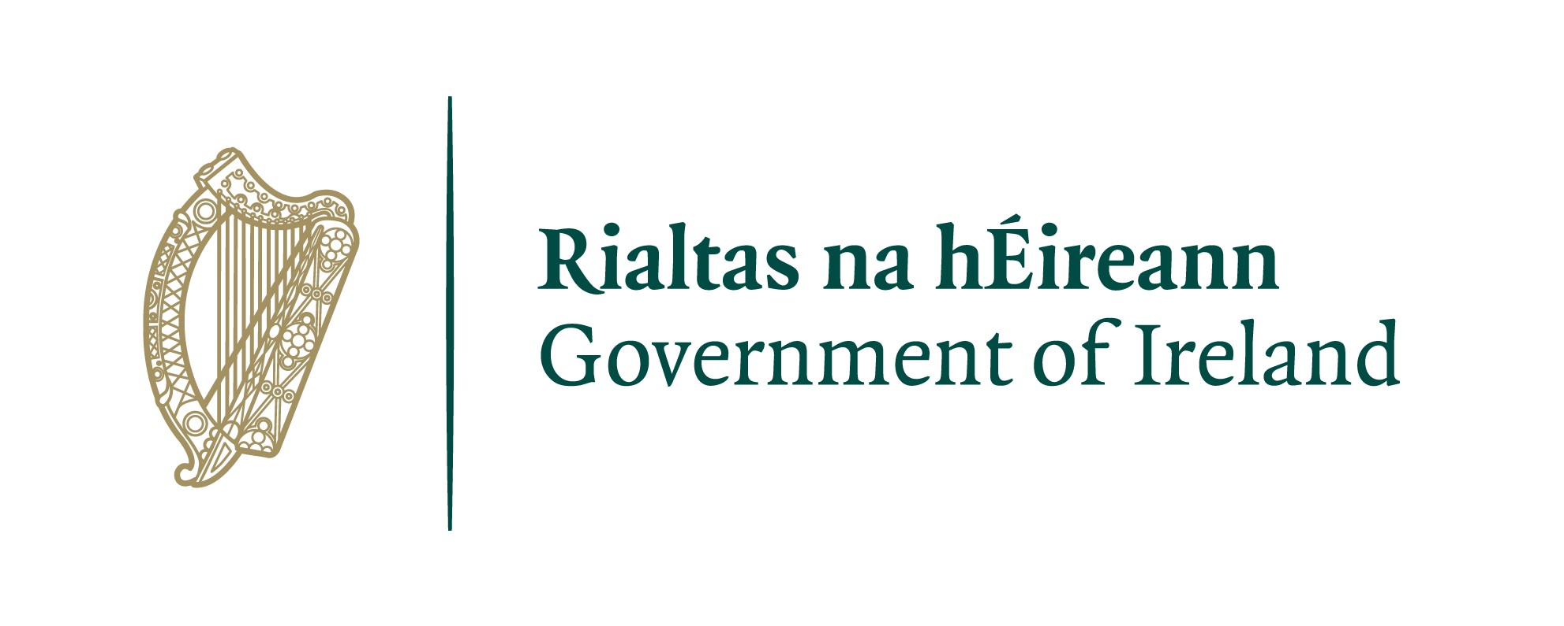
The Cultúr MNCD project is funded by Department of Rural and Community Development

